Sound–color synesthesia (chromesthesia)

🎨👂 What is Sound–Color Synesthesia?
# Source: AI Source: Provided by: [Data Path: Persons Table -> ID Column: 1, Name_En Column: Motasem Essam] -> From: [Chatgpt (GPT-4-turbo)] on [7/24/2025]
Sound–color synesthesia (also called chromesthesia) is a rare neurological condition in which hearing sounds (like music, voices, or noises) automatically triggers the perception of colors — even though those colors aren’t actually present.

📘 Definition:
# Source: AI Source: Provided by: [Data Path: Persons Table -> ID Column: 1, Name_En Column: Motasem Essam] -> From: [Chatgpt (GPT-4-turbo)] on [7/24/2025]
Sound–color synesthesia is a type of synesthesia in which auditory stimuli (such as tones, pitches, instruments, or words) trigger the involuntary experience of color.

🧠 How It Works:
# Source: AI Source: Provided by: [Data Path: Persons Table -> ID Column: 1, Name_En Column: Motasem Essam] -> From: [Chatgpt (GPT-4-turbo)] on [7/24/2025]
- A person might see flashes of blue when hearing a trumpet.
- Or, a voice speaking might appear to them as a red shape in their mind’s eye.
- The color is not chosen — it just happens automatically and consistently.

🎼🎨 Common Triggers in Sound–Color Synesthesia:
# Source: AI Source: Provided by: [Data Path: Persons Table -> ID Column: 1, Name_En Column: Motasem Essam] -> From: [Chatgpt (GPT-4-turbo)] on [7/24/2025]

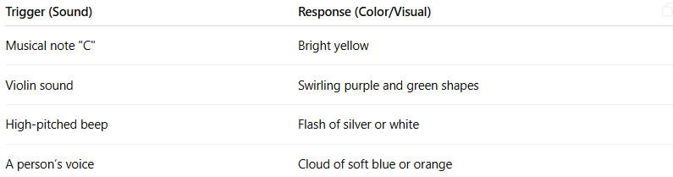

Trigger (Sound) | Response (Color/Visual)
Musical note "C" | Bright yellow
Violin sound | Swirling purple and green shapes
High-pitched beep | Flash of silver or white
A person’s voice | Cloud of soft blue or orange
Different synesthetes experience different pairings, but each person’s associations tend to be consistent over time.

Sound–color synesthesia photo
# Source: Windows ScreenShots at [7/26/2025]
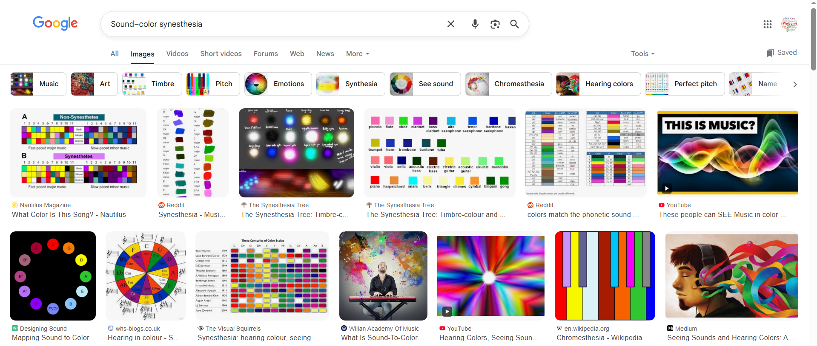
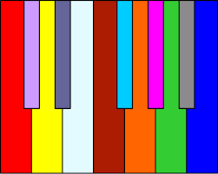
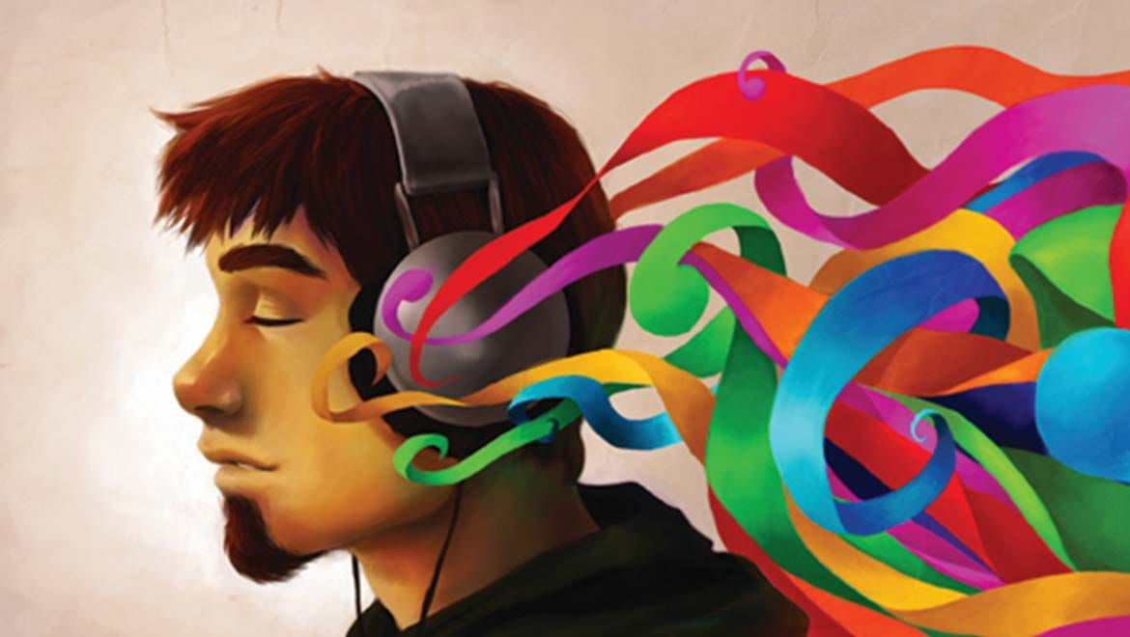

🔬 Why It Happens:
# Source: AI Source: Provided by: [Data Path: Persons Table -> ID Column: 1, Name_En Column: Motasem Essam] -> From: [Chatgpt (GPT-4-turbo)] on [7/24/2025]
- Thought to be caused by extra connections between auditory and visual areas in the brain.
- It is neurological, not imaginary — brain scans show real activity in color-processing areas when synesthetes hear sounds.
- It’s not a disorder — it’s a natural variation in sensory processing.

🧬 Related Types of Synesthesia:
# Source: AI Source: Provided by: [Data Path: Persons Table -> ID Column: 1, Name_En Column: Motasem Essam] -> From: [Chatgpt (GPT-4-turbo)] on [7/24/2025]


Type | Stimulus | Response
Grapheme–color synesthesia | Letters/numbers | Colors
Chromesthesia | Sounds (music/speech) | Colors/shapes
Lexical–gustatory | Words | Tastes

✅ Summary:
# Source: AI Source: Provided by: [Data Path: Persons Table -> ID Column: 1, Name_En Column: Motasem Essam] -> From: [Chatgpt (GPT-4-turbo)] on [7/24/2025]
Sound–color synesthesia (chromesthesia) is when hearing sounds automatically causes a person to see colors — either in their mind’s eye or as part of their sensory experience.
It is involuntary, consistent, and unique to each person.

